Malawi Compost Transporter

Final Proposal

Husain Aldawood
Connor Schmerfeld
Hope Williams
Shi Zhang

Spring 2021



Project Sponsor/Faculty Advisor/Sponsor Mentor: Dianne McDonnell
Instructor: David Trevas

DISCLAIMER
This report was prepared by students as part of a university course requirement. While considerable effort has been put into the project, it is not the work of licensed engineers and has not undergone the extensive verification that is common in the profession. The information, data, conclusions, and content of this report should not be relied on or utilized without thorough, independent testing and verification. University faculty members may have been associated with this project as advisors, sponsors, or course instructors, but as such they are not responsible for the accuracy of results or conclusions.

EXECUTIVE SUMMARY
Malawi is a small landlocked country in the southeastern region of Africa. It is also considered one of the poorest countries in the world, located in the southeastern region of Africa. To make better use of organic materials found in Malawi, locals have set up composting sites where residents can dispose of compostable materials. To ease the transport of this compostable material, Team Malawi has been tasked to design and engineer a tricycle that can transport compost from tightly-packed neighborhoods to the composting sites.

Team Malawi was given this project last semester, spring 2020, as a ME 386W project. The team has now decided to continue this project and build the device to help the people of Malawi. Our team started this project by talking with our client, Dr. McDonnell, and understanding what her needs and the people of Malawi’s needs are. After meeting with the client, the team was able to come up with constraints and requirements for the design. After weighing the customer needs and engineering requirements, Team Malawi created design alternatives and scored each with the given criteria. This process was done by making charts such as a morphological matrix, Pugh chart, and decision matrix which can all be seen below. This process left the team with a final design that met all of the engineering requirements and customer needs. The cart will be powered by two batteries and a DC Motor that has enough capacity and power to run the vehicle. The team also made a rough CAD model to represent the design in a three-dimensional view. The total cost of the design the team has calculated is $1404.94. This number is below the budget our client has provided us which gives the team some room to make more purchases if needed during the trial and error stage. The spring 2021 semester will consist of building and testing our final device in order to hopefully achieve a successful vehicle to help the people of Malawi. We had quite a bit of trouble getting the tires in and we actually finally received them during the second to last week of school. We also had trouble with wiring the DC motor and connecting it to the batteries, speed controller, and electric throttle. The team will ask for further help from the electrical engineering department as we are not very familiar with motors and the wiring behind them. The team was able to use loads up to 500 pounds, the client requirement, and we were able to successfully pull this amount of load. Overall, the team is very happy with what we were able to make and produce and we are excited to see how it is implemented in the country of Malawi.

ACKNOWLEDGEMENTS
Thank you to our client, Dr, McDonnell, for providing us with all the necessary information for this project. She was a huge help in giving the team an idea of what to do and has been an amazing client to work with. Also a huge thank you to Dr. David Trevas and Dr. David Willy for guidance with certain aspects of the project. Our capstone instructor, Dr. David Trevas, kept us on track through the semester with weekly meetings and email updates informing us what we needed to get done.
Another special thanks to Precision Tire and Auto Center in Phoenix for assisting in the machining and welding of the rear axle of this cart.

TABLE OF CONTENTS
Contents
TITLE PAGE 1
DISCLAIMER 2
EXECUTIVE SUMMARY 3
ACKNOWLEDGEMENTS 4
TABLE OF CONTENTS 5
1 BACKGROUND 8
1.1 Introduction 8
1.2 Project Description 8
2 REQUIREMENTS 9
2.1 Customer Requirements (CRs) 9
2.2 Engineering Requirements (ERs) 10
2.3 Functional Decomposition 10
2.3.1 Black Box Model 10
2.3.2 Functional Model/Work-Process Diagram/Hierarchical Task Analysis 11
2.4 House of Quality (HoQ) 12
2.5 Standards, Codes, and Regulations 12
3 DESIGN SPACE RESEARCH 13
3.1 Literature Review 13
3.2 Benchmarking 13
3.2.1 System Level Benchmarking 14
3.2.1.1 Existing Design #1: Wheelbarrow 14
3.2.1.2 Existing Design #2: Gorilla Cart 14
3.2.1.3 Existing Design #3: Cushman Truckster 15
3.2.2 Subsystem Level Benchmarking 15
3.2.2.1 Subsystem #1: Dumping Mechanism 16
3.2.2.1.1 Existing Design #1: Wheelbarrow 16
3.2.2.1.2 Existing Design #2: Gorilla Cart 16
3.2.2.1.3 Existing Design #3: Cushman Truckster 16
3.2.2.2 Subsystem #2: Descriptive Title 16
3.2.2.2.1 Existing Design #1: Wheelbarrow 16
3.2.2.2.2 Existing Design #2: Gorilla Cart 16
3.2.2.2.3 Existing Design #3: Cushman Truckster 16
3.2.2.3 Subsystem #3: Descriptive Title 16
3.2.2.3.1 Existing Design #1: Wheelbarrow 17
3.2.2.3.2 Existing Design #2: Gorilla Cart 17
3.2.2.3.3 Existing Design #3: Descriptive Title 17
4 CONCEPT GENERATION 18
4.1 Full System Concept 18
4.1.1 Full System Design #1: Off-road Self-propelled Wagon 18
4.1.2 Full System Design #2: Bicycle on Tracks 19
4.1.3 Full System Design #3: Off-Road Wagon 19
4.2 Subsystem Concepts 20
4.2.1 Subsystem #1: Dumping Mechanism 20
4.2.1.1 Design #1: Hydraulic System 20
4.2.1.2 Design #2: Screw Jacks 21
4.2.1.3 Design #3: Scissor Lift 21
4.2.2 Subsystem #2: Tires/Traction 22
4.2.2.1 Design #1: Air Filled Tires 22
4.2.2.2 Design #2: Regular Foam Filled Tires 22
4.2.2.3 Design #3: Sealant Foam Filled Tires 23
4.2.3 Subsystem #3: Motor/Power 23
4.2.3.1 Design #1: Operator and Motor Powered 23
5 DESIGN SELECTED – First Semester 24
5.1 Design Description 24
5.2 Implementation Plan 25
6 IMPLEMENTATION – Second Semester 27
6.1 Design Changes in Second Semester 27
6.1.1 Design Iteration 1: Change in [subsystem/component] discussion 27
6.2 Manufacturing and Assembly Plan 27
7 RISK ANALYSIS AND MITIGATION 30
7.1 Potential Failures Identified Fall Semester 30
7.2 Potential Failures Identified This Semester 30
7.3 Risk Mitigation 30
8 ER Proofs 32
8.1 ER Proof #1 – Compact Size 32
8.1.1 3x4ft Bed-Target = 12 sq. ft. with 6in. high walls 32
8.1.2 3x4ft Bed-Target Tolerance = +/- 2 in 32
8.2 ER Proof #2 – High Capacity Battery 32
8.2.1 Capacity of at least 10 Amp-hours- Target = 10 Ah 32
8.2.2 Capacity of at least 10 Amp-hours - Tolerance + +/- 2Ah 32
8.3 ER Proof #2 – Cost under $1,500 32
8.3.1 Cost under $1,500 - Target = $1.250 32
8.3.2 Cost under $1,500 - Tolerance = +/- $387 33
9 LOOKING FORWARD 34
9.1 Future Testing Procedures 34
9.1.1 Testing Procedure 1: Descriptive Title 34
9.1.1.1 Testing Procedure 1: Objective 34
9.1.1.2 Testing Procedure 1: Resources Required 34
9.1.1.3 Testing Procedure 1: Schedule 34
9.1.2 Testing Procedure 2: Descriptive Title 34
9.1.2.1 Testing Procedure 2: Objective 34
9.1.2.2 Testing Procedure 2: Resources Required 34
9.1.2.3 Testing Procedure 2: Schedule 34
9.2 Future Work 35
10 CONCLUSIONS 36
10.1 Reflection 36
10.2 Post Mortem Analysis of Capstone 36
10.2.1 Contributors to Project Success 36
10.2.2 Opportunities/areas for improvement 38
11 REFERENCES 39
12 APPENDICES 42
12.1 Appendix A: Design Alternatives 42
12.2 Appendix B: Important Tables 45

BACKGROUND

Introduction
Apart from being a small landlocked nation in Africa’s southeastern region, Malawi is also regarded as one of the world’s poorest countries. For better utilization of organic materials found in this country, residents have set up places for disposing of compostable waste materials. To ensure easy transportation of these compostable waste materials, our team has been mandated to design and make a tricycle that is able to transport compost to the composting location. The group was acquainted with the customer that will be with us for the degree of the semester and further if the venture is to be proceeded. In the wake of meeting with the client, the group had the option to concoct imperatives and prerequisites for the plan. Subsequent to gauging the client's needs and designing prerequisites, The team made plan options and scored each with the given measures. This cycle was finished by making diagrams, for example, a morphological framework, pugh outline, and choice grid which would all be able to be seen beneath. This cycle left the group with the last plan that met all of the designing necessities and client requirements. A lithium-ion battery with sufficient capacity will be used to power the tricycle. A CAD model was made as a representation of the design in a 3-dimensional view. Cost analysis of the design can also be seen below as well so the team is prepared how much the final design will cost if chosen to manufacture. Through the design process that is shown below, our team has come up with an optimal design that will improve the lives of the people of Malawi. This project proposal is a compilation of all work that was put into the design of the compost transporter in Malawi. The information inside this update start from the earliest starting point of the undertaking, which is the difficult definition. This incorporates the client’s needs, designing prerequisites, and a figure of the QFD that was made joining the two. The group was then ready to contemplate distinctive designing investigations of the plan. In the wake of having a rough drawing of what the last plan will resemble, the group planned a CAD model. From the CAD model, the group had the option to deliver some cost analysis. This incorporates a bill of materials, the assembling cost, the existence cycle cost, the worth examination, and a period estimation of cash. Ultimately, on the report will be a code of morals that incorporates the conceivable moral issues the group may experience.

Project Description
The main goal of this project is to design and make an electrically propelled tricycle that will allow Malawians to transport organic waste materials from their home to compost sites. Organic waste entails but is not limited to garbage, junk, and any other materials considered pollutant to the environment due to their toxicity. The partners for the task incorporate the individuals of Malawi who will be working the vehicle. Another partner is the whole nation of Malawi in light of the fact that, if fruitful, the tricycle will improve the work of the entire Malawian populace. The group accepts that the necessities of the customer and the partners are fundamentally the same as and meet the general objective. To address their issues, the vehicle should be effectively viable and manufactured with some normal homegrown materials to ease fixes. The vehicle additionally should be anything but difficult to work with practically zero electrical information required. Being lightweight and smaller is extremely useful as long as it is as yet ready to keep up a high payload limit and strength. The objective satisfies these necessities by assessing all client requirements and applying an answer for all prerequisites the clients needed.

REQUIREMENTS
When meeting with the client, the team came up with a list of customer needs that must be met in order to satisfy the client. After the customer needs were developed, the team came up with a list of engineering requirements within the QFD. A more in-depth list of customer needs and engineering requirements based on the must-haves and nice to haves.

Customer Requirements (CRs)
In order to understand what the client and people of Malawi want, the group met with Professor McDonnell, our client, and she gave us a list of requirements that she would like to see in the project. She has talked to the people of Malawi as well and included their requirements along with her list. She broke it down into two individual groups: must-have, and nice to have. These two lists can be seen below in more detail.
Must Have:
- Maintainable
- Manufacturable
- Durable
- Lightweight
- Easy to Operate
- Maneuverable Size
- Operable on Muddy Roads
- Cost within budget
- Durable and Robust design
- Reliable design
- Safe to operate

All of the items in the above list are items that the project needs to have, according to the professor and instructor. It must be maintainable, as Malawi is a poor country and can’t be constantly buying new parts. It must be manufacturable since the end goal is to be able to make multiple for this country. It needs to be durable, lightweight, and operable on muddy roads because there are no paved roads and this design is going to be in constant use. The roads are also very narrow, making the device a reasonable size. Malawi also gets a lot of rain and when the roads turn muddy, the cart still needs to be able to operate. It must be reliable for this same reason, as well. It needs to be safe and easy to operate, as these will be used every day by people, mainly women, and children. Finally, it needs to be within the budget of $1,500, as told by the instructor.

Nice to Have:
- High Capacity
- Rechargeable
- Reusable Materials Found in Malawi

The “nice-to-have” items listed above were given by the client as things to think about when making this project, but not necessarily adding them in right away. She did this because this project is going to go well past the year this group was given, so she wants this group to give future groups a good jumping-off point, where they can hopefully include these if they aren’t already included.

Engineering Requirements (ERs)
After hearing what the client wanted for this project, the group decided to come up with a list of engineering requirements to think about when designing. The engineering requirements are items that are measurable and are items that we are able to discuss quantitatively. This list can be seen below.
- Increase Power
- Small Dimensions
- Increase Waste Capacity
- Increase Battery Life
- Decrease Weight
- Decrease Manufacturing Cost
- High Level of Safety

Power is something that the group will constantly need to think about, as we will be dealing with electric motors and carrying a load capacity up to 500 pounds. The design should have smaller dimensions, but still maximize load capacity for travel as well as storage. This design should take up as little space as possible without making it useless in terms of waste capacity. In order to increase the battery life, the team has decided to make it both motorized and have a handle to be human powered as well. This will increase the battery life because it won't have to constantly be running and can get pulled in between short distances. The design should be as light as possible due to muddy roads and the possibility of getting stuck. The civilians that will be using the cart, which keeping in mind will be mainly women and children, should be able to push or pull the design out, maybe with the help of multiple people. Finally, the group is going to be constantly keeping track of the manufacturing cost. This is due to being restricted by the budget our instructor, Dr. Trevas, has given us, as well as the Customer Need of wanting to one day make multiple carts.

Functional Decomposition
To start designing a cart which meets all of our customer and client needs, we made a black box model to breakdown the inputs and outputs of this design. Using this information, we made a functional model to further break down the inputs and outputs. A figure of both of these can be seen below as well as a more in depth description.

Black Box Model
This section discusses the Black Box Model of this project. A Black Box Model allows the group to focus solely on the inputs and outputs of this project without having to worry about the details of how to get from one to another. The Black Box can be seen below.

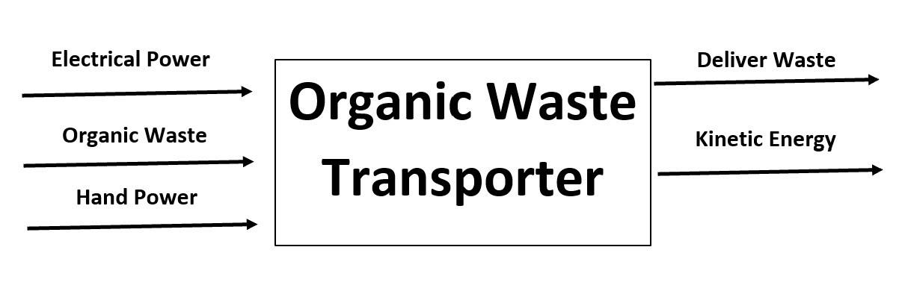
Figure 1: Black Box Model

The primary inputs of the design are electric and hand power, as well as organic waste. The outcome of this design will deliver waste as well as outputting kinetic energy. A Black Box model is important when starting a project because it allows the group to see the bigger picture and get a scope of what the project is going to need. It also allows the group to start thinking about what is inside of the “Black Box”.

Functional Model/Work-Process Diagram/Hierarchical Task Analysis

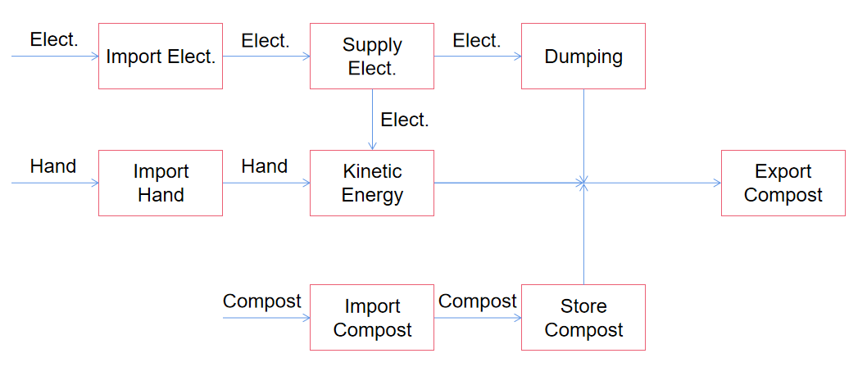
Figure 2: Functional Model
A functional model is a graphical description of the functions (or operations) a product must perform on input flows to transform them into desired output flows. Sub-functions may be derived from customer needs. Then solutions to sub-functions can be directly tied to the customer's needs. All in all, according to the function allocation of the functional model, it can help the team to more specifically clarify the availability of designs.

House of Quality (HoQ)
After taking all the data, we began to analyze the information and compiled it into a more useful form. This form is known as the QFD chart. This is a chart used by engineers to focus on what they are trying to accomplish. In this chart, the customer needs and engineering requirements of such a device are analyzed and compared in order to better understand what this device needs to do. The scale used in this QFD is a standard scale of importance. After computing the absolute technical importance of each engineering requirement, our team came to the three most important engineering requirements: (1) High level of safety (2) Increase power and (3) Small dimensions.

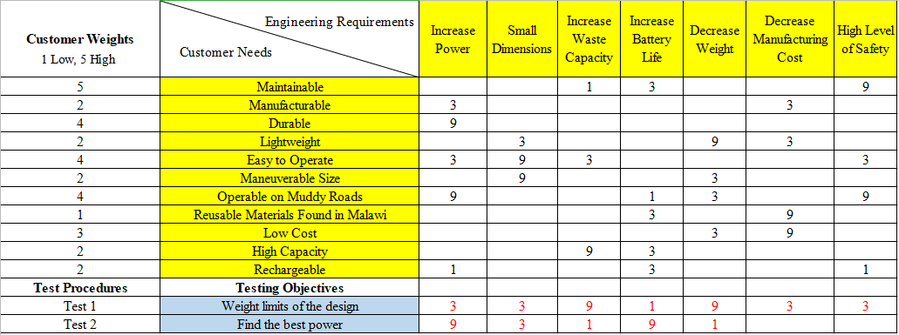Figure 3: House of Quality

Updates to the QFD include added testing procedures and their quantitative relationship to the engineering requirements. Tests are listed below the customer requirements section, including two tests that ensure the operation of all main components. The relationship correlation between tests and engineering requirements are depicted in red.

Standards, Codes, and Regulations
The only standards this project requires is a dimensioning standard and the customer and clients needs. The only reason a dimensioning standard is needed is so that the design can be converted between dimensions or be given specific tolerances. Because this is a new project, there are no regulations associated with it and our goal is to simply come up with the most efficient and affordable design to support our client.

DESIGN SPACE RESEARCH
In this chapter, a variety of ways to design the project will be discussed. The group each conducted a literature review in which they did their own individual research on certain aspects of the project. With each aspect, the group is able to come together with their newfound knowledge and discuss ways to put each concept together. Following the literature review, a benchmarking analysis was conducted. The group took the time to find products that are already on the market that are relevant to this project. These are products that aren’t necessarily geared towards this specific project, but could be viable options. These are also products that can be useful when designing the final product where the team can pick and choose certain aspects from each item.

Literature Review
Each student conducted their own literature review. Each one focused on their own specific topic. This was done so that once each student finished, they could come together and discuss their findings. In doing so, they could decide on what may be the best way of going about the design of this project. In last semester, each student described their method and research below. This semester, we briefly summarize our findings. The technical aspect that Shi focused on was the dumping mechanism. What we need to do is to fix one end of the trailer with screws, and then lift up the other end to realize dumping. After a lot of investigation, Shi believes that our team can use jacks, scissor lifts, hydraulic rods, and pulley systems to dump. Connor’s main area of focus was the 8020 Aluminum that was recommended by the client. 8020 Aluminum is an aluminum manufacturing company that makes certain profiles that are easy to assemble and disassemble. The task given was to go through a schooling on their website called “8020 University” which allows the user to learn the basics on everything about the 8020 aluminum pieces. After going through the university, Connor was given the task of conducting a beam analysis on 8020 aluminum to see if this material would be feasible. This was done using the moment of inertia and moment to find the max bending stress, then comparing this to the yield strength. The moment of inertia was already given through the university, so all that was needed was the max bending moment. This was found by putting a distributed load onto the beam and constructing a Shear-Force-Diagram and then a Bending-Moment-Diagram. The individual analysis Hope has been assigned is to find which motor will best suit the final design based on our current known values and assumptions. This includes researching the different types of motors currently available on the market and listing the pros and cons that come with each motor. With Hope’s research, she believes an AC motor will be the best option for our design. When comparing to a DC motor, Hope has found AC motors take less maintenance and in the long run are cheaper. DC motors have high maintenance costs and extra costs for changing the brushes. After discussing in more detail with our client Dr. McDonnell, the team has decided to make the final design both human and motor powered. Because the cart doesn’t have to travel far distances from house to house, starting a motor to travel ten feet will not be worth it. The team and client have decided to also make it chain driven. The technical analysis assigned to Husain is focusing on the best tires that will best suit the project. choosing the best tires required a lot of research and analysis. With Husain’s research and analysis, it became clear that foam tires would be the best choice for our project. Having foam filled up tires can have two important aspects in the project. The first aspect is that tires filled with foam can avoid punctures. Also, the weight of the foam can be an extra counterweight, which allows the machine to work with more stability in higher altitudes than tires filled with air only.

Benchmarking
In order to begin the benchmarking process, the group researched products that are already on the market that could be a viable alternative for this project. The three most similar products found were the classic wheelbarrow, the Gorilla Cart, and the Cushman Truckster. Each of these are products that can satisfy multiple needs from the client. However, each of them also have their own downfalls. The following section will discuss each of these pros and cons of each product and how they would not make it a perfect fit for this project.

System Level Benchmarking
This part discusses existing designs at the system level. Before diving into more detailed subsystems, it is best to start with looking at and comparing each system as a whole. The three existing products, as listed above, will be compared to each other and will discuss how well they fit within the client’s needs.

Existing Design #1: Wheelbarrow
This existing design is probably the most basic of them. When someone thinks about carrying compost, a wheelbarrow typically is thought of. A wheelbarrow is a one-wheeled cart that is lifted and guided by a person. The person can both pull or push this design. This meets the customer needs in the way that it is durable, it can carry high loads, and it is cheap and easy to operate. Where this design lacks is in maneuverability and power. The only power given is by the human operating it, therefore the limit is only as high as the strength of the operator. Not only that, but it can be very difficult to maneuver a wheelbarrow through dirt roads and mud.
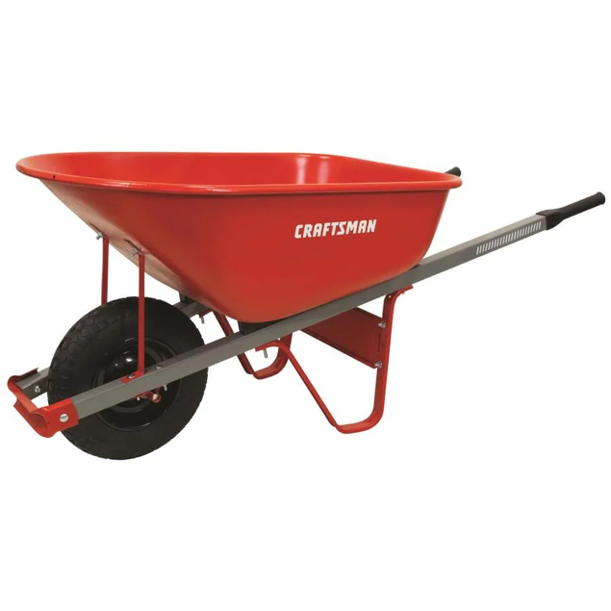
Figure 4: Wheelbarrow [11]

Existing Design #2: Gorilla Cart
This design is a slightly modified version of the wheelbarrow. It is a four-wheeled cart that can be pulled by an operator. This design fits every need that the wheelbarrow does, but is also more maneuverable. With four wheels instead of one, this design is much easier to control. It even has some options that dump the load using the force of gravity. The downside to this design is that, once again, it relies all on the operator. The limits of how much can be towed relies directly on how strong the person pulling it is.
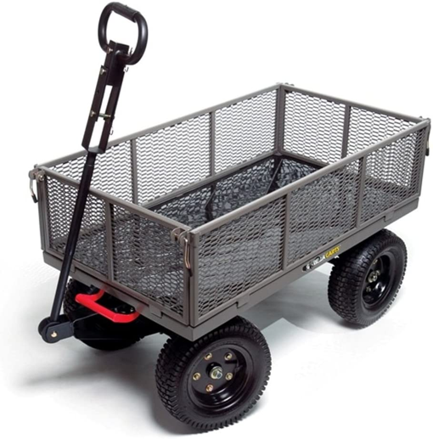
Figure 5: Gorilla Cart [12]

Existing Design #3: Cushman Truckster
The Cushman Truckster, as seen below, is another existing design that could meet most of the needs of the client. This is a very durable design, operating on three wheels with a large load capacity. This design is also motorized, which eliminates the human power limit. This also meets the need of being manufacturable. However, this product would not move well in narrow and muddy terrain. It is also a gas powered vehicle which can be very difficult to maintain at such a low cost. It is already not very budget friendly, with this 1954 model below selling for $6,600.

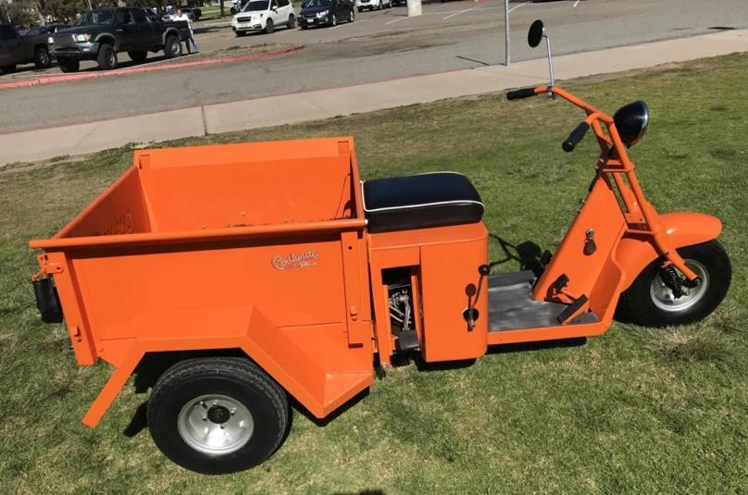
Figure 6: Cushman Truckster (1954) [13]

Subsystem Level Benchmarking
Now that each product has been looked at on a general basis, the group can look into more detailed aspects of the system and compare those. The three subsystems that will be discussed are the dumping mechanism, the tires/traction, and the motor/power of each product. The reason behind looking at smaller aspects of these designs is to get a better understanding of each component so that the group can put what works best on their overall system.

Subsystem #1: Dumping Mechanism
After the workers deliver the compost to the designated place, our team hopes that our equipment will have a dumping mechanism. Specifically, one end of the trailer will be fixed and then the other end will be lifted up. Then the compost will be poured out due to gravity, which will make the whole equipment more convenient to operate. Also, it can improve the work efficiency and reduce the workload of the workers.

Existing Design #1: Wheelbarrow
This existing design is probably the most basic of them. It has small dimensions and light-weight, and workers can easily lift the wheelbarrow by hand to realize dumping. This dumping mechanism is suitable for the time when the weight of compost is light and the transportation distance is short.

Existing Design #2: Gorilla Cart
This existing design has a hydraulic rod, and a motor is installed on the trailer to drive the hydraulic rod, workers can remotely control the motor to control the extension of the hydraulic rod, which can realize automatic dumping.

Existing Design #3: Cushman Truckster
This design has two wheels instead of having only one wheel. It has small dimensions and light-weight, workers can grab the hook as a handle to lift the trailer.

Subsystem #2: Tires/Traction
Tires are a really important subsystem for our design. The tires are what allows the device to travel to and from places much easier. Along with the type of tires, the number of tires also affects the design differently. Our client has stated 3 or 4 tires is the most desirable for our final design. A description of the tires for the existing designs is found below.

Existing Design #1: Wheelbarrow
Wheelbarrows usually have one tire to give the device the ability to push and turn around faster. This 360 rotation allows the user to be able to push big loads in all directions.

Existing Design #2: Gorilla Cart
Gorilla Carts are equipped with four off-road tires. These carts are known for having durable wheels, as many of them are foam filled or partially foam-filled. This allows for a larger weight capacity without blowing a tire off.

Existing Design #3: Cushman Truckster
The Cushman Truckster comes with three wheels, which allows for sharper turns. The downside to this product’s tires is that they are small tires that are typically street-tread. This wouldn’t be ideal for rough, dirt roads.

Subsystem #3: Motor/Power
The powering of the system is a really big part of the design. Without a way to power it, the cart will not move and therefore defeats the purpose of the design. The team has discussed this subsystem with the client and had agreed we want our final design to have a motor to travel to and from the disposal site as well as making it human powered for shorter distances.

Existing Design #1: Wheelbarrow
For the first design, a wheelbarrow, it is strictly human powered. The wheelbarrow is only capable of moving if a human or animal pushes it. This is one of our requirements but is lacking the motor powered requirement the client wants.

Existing Design #2: Gorilla Cart
The Gorilla cart is similar to the wheelbarrow but has four wheels rather than one. It is also solely based on human or animal power and is therefore lacking the motor power the client wants.

Existing Design #3: Cushman Truckster
The last existing design is the Cushman Truckster. This design is motorized, but lacks the operator power. The team's overall goal is to come up with a design that incorporates all three of the existing designs into one and fits our client’s needs.

CONCEPT GENERATION
Now that a Benchmarking Analysis has been completed, the group could start to come up with concepts for this project. The benchmarking allowed for the group to find what will work and what will not for this project. In this chapter, the group discusses three of the six alternative designs in depth, using both a Full-System analysis and a subsystem analysis. These three designs were chosen to go into detail because these three are very different from each other and offer the most variety in combinations. These three alternatives allow the group to compare specific parts of each design to each other in order to make the best choice for this project. The rest of the designs can be seen in Appendix A.

Full System Concepts
Below are three design concepts that the group has come up with. Each one will be compared both at a full system level and a subsystem level. This section covers the Full system level where each design will be compared to each other as a whole and how each one fits the customer needs in some way, if at all.

Full System Design #1: Off-road Self-propelled Wagon
This design is a self propelled vehicle, using an AC motor and remote control to operate and handle it. Inside, there is a hydraulic piston-like assembly that retracts when a load is being hauled and can be expanded at the push of a button when ready to push the load out. This concept works well in many ways but also fails in others.This design works well because it completely eliminates human power. The operator will just walk along with it and be sure that nothing goes wrong along the way. Another way this exceeds is by the load. The load can be stored and released just as easily. One of the main problems is functionality. This design heavily relies on technology and a good radio frequency connection. If the remote or wagon batteries die, it becomes a completely useless piece of machinery until the battery is replaced. Because of this, this design is not maintainable, nor is it easy to operate due to the wide array of technological controls.
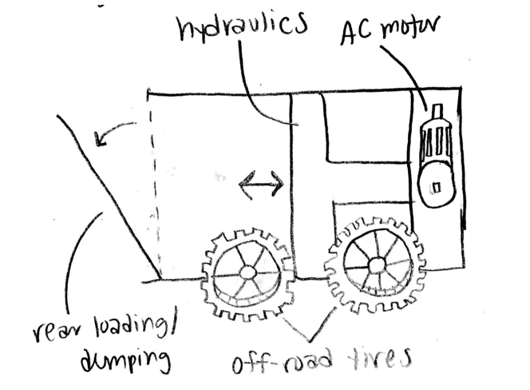
Figure 7: First Design, labeled the Self-Propelled Wagon

Full System Design #2: Bicycle on Tracks
This design, as shown below, is a motorized wagon that the user rides to and from their destination. The piece that sets this off from the rest is the traction. Instead of using tires, this design brings in the concept of tracks, similar to that of a tank. This design heavily focuses on satisfying the need for traction and durability. This is also a design that would be relatively easy to operate. There are a number of problems that make this design not ideal, however. The first problem is maintaining the product. Tracks can be very expensive and very difficult to replace. Not only that, but this design is similar to the first in the way that this would be dead weight if a batter were to die. Another possible problem is that the cargo capacity would probably be very minimal to decrease the overall length of the concept. There are a number of things that would need to be improved if this design is chosen.
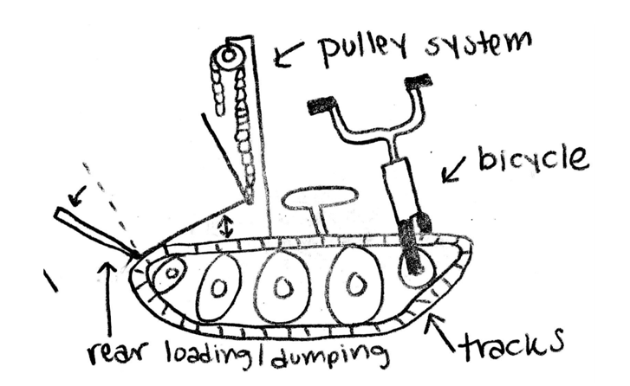
Figure 8: The second design, a Bicycle on Tracks similar to a tank’s

Full System Design #3: Off-Road Wagon
This final design is one of the simplest, yet possibly one of the most practical. It uses off-road wheels and a hydraulic lifting system to dump the load. The cart is electrically propelled and guided by an operator on a handle. This design is very maneuverable and maintainable, as there aren’t many electrical components nor are there many complex pieces. The advantage that this design has over the rest is that it can be both electrically assisted or solely human-powered. This way, if the battery dies, the cart can still be used to an extent until the battery is charged or replaced. The largest downside to this design is that it may not do the best in muddy terrain, but this depends mainly on the size and clearance of the cart.
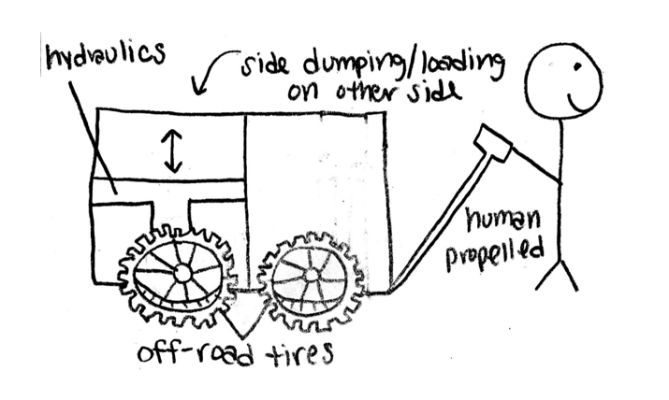
Figure 9: The third design, simply labeled the Off-Road Wagon

Subsystem Concepts
These designs can be broken down into more specific areas. As with the Existing Products, these design alternatives were looked at more closely. This is an important part of the design process because it allows the user to see how each of the important components of the project are reflected in each design. Below are subsystems that were incorporated into the design alternatives. Within each subsystem, there are multiple designs that have been compared to one another in order to determine which would be best for this project.

Subsystem #1: Dumping Mechanism
What our team needs to do is to fix one end of the trailer with screws, and then lift up the other end. Due to the effect of gravity, the compost will be poured out to realize dumping. This will reduce the burden on workers and improve work efficiency.

4.2.1.1 Design #1: Hydraulic System
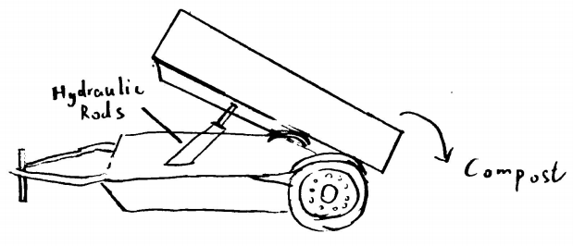
Figure 10: Dumping Mechanism - Hydraulic System

The workers will remotely control the motor to control the expansion and extension of the hydraulic rod to realize dumping.
Advantages: Operate remotely; Automatic dumping.
Disadvantages: High manufacturing costs; High maintenance costs.

4.2.1.2 Design #2: Screw Jacks
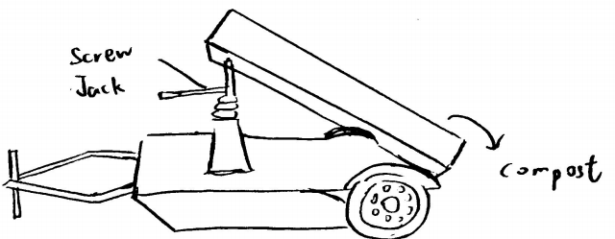
Figure 11: Dumping Mechanism - Screw Jacks

The workers will use a screw jack to lift one end of the trailer to achieve dumping.
Advantages: Low manufacturing costs; Low maintenance costs.
Disadvantages: Vibration during the process (unstable); Workers need to turn the handle on the jack by hand.

4.2.1.3 Design #3: Scissor Lift
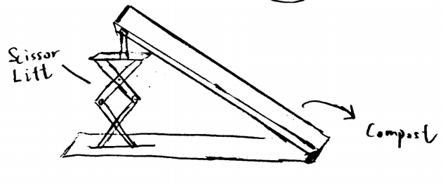
Figure 12: Dumping Mechanism - Scissor Lift

Our team will weld the scissor lift with the trailer before, and lift the trailer through remote control of scissor lift's expansion and contraction.
Advantages: Operate remotely; Automatic dumping.
Disadvantages: High manufacturing costs; High maintenance costs.

4.2.2 Subsystem #2: Tires/Traction
Based on our needs, tires are so important for the stability of our vehicle. Moreover, tires can determine if our vehicle can go through the rough terrain in Malawi without failing by getting stuck or simply getting punctures. So, tires can determine if our vehicle can run efficiently as intended, which means that tires are a very essential part of our project.

4.2.2.1 Design #1: Air Filled Tires
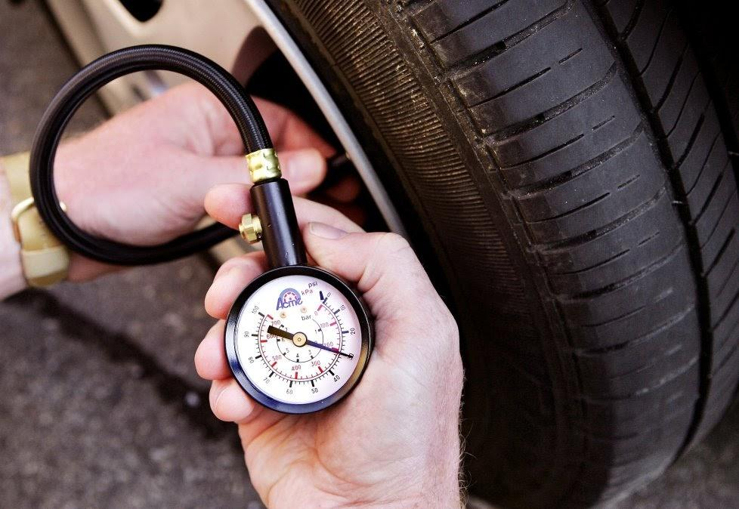
Figure13#: Tires/Traction - Air Filled Tires

Rubber tires filled with air, which is pretty common on most cars and cost efficient.
Advantages: Cost efficient; easily inflatable .
Disadvantages: Durability; Prone to Punctures.

4.2.2.2 Design #2: Regular Foam Filled Tires
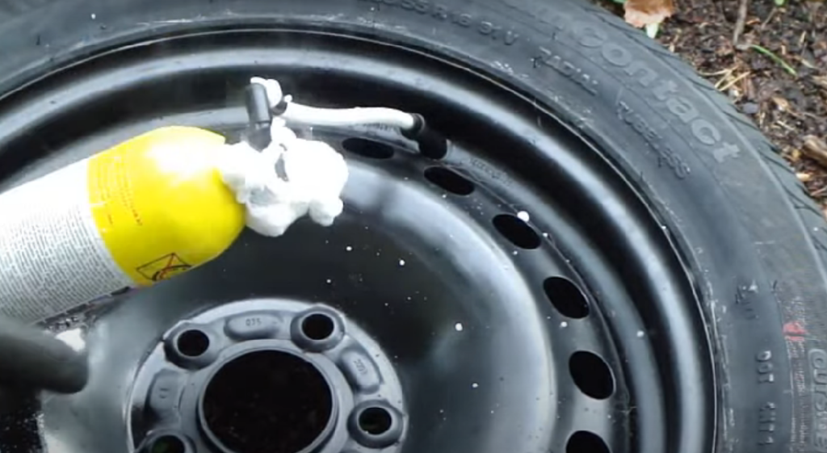
Figure 14: Tires/Traction - Regular Foam Filled Tires

Rubber tires filled with foam, which is a great idea for shock absorbent.
Advantages: Shock absorbent; more flexibility.
Disadvantages: More materials needed; needs a sealant to the rim.

4.2.2.3 Design #3: Sealant Foam Filled Tires
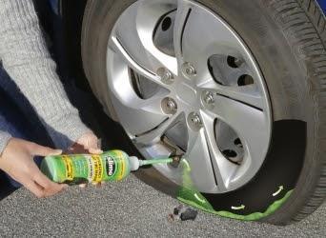
Figure 15: Tires/Traction - Sealant Foam Filled Tires

Rubber tires filled with sealant foam, which is a concept that has been around for a few years.
Advantages: Availability; easy to get in the market, Sealant; It’s a rim-tire sealant foam.
Disadvantages: Cost; More expensive on the budget.

4.2.3 Subsystem #3: Motor/Power
The team has discussed with the client the multiple ways to power a cart and has decided on one which we believe fits Malawi and the people of Malawi's needs. Below is a more in depth description of the design we have chosen and why.

4.2.3.1 Design #1: Operator and Motor Powered
The team has decided to have two different ways to power the cart including operator power and motor power. We will use an AC motor to power the device when it needs to go long distances such as to and from the disposal site, and human powered when traveling shorter distances like to and from each house. Only using the motor during long distances will make it last longer because it won’t be running all day. This will also save money and make the motors have a longer life span. We believe incorporating both of these fits the customer needs the best and will be the most beneficial to the people of Malawi.

5 DESIGN SELECTED – First Semester
In Designs Selected, we will combine the subsystems we come up with and create the concepts. Then we got our six designs which are shown in Appendix A. Firstly, we will use the Pugh Chart to narrow six designs down to three by ranking them based on customer needs. Then we will use the Decision Matrix to decide our top one design based on engineering requirements. Another design will be decided by team members to make up for the deficiencies of the design selected by decision matrix. The design selected includes a combination of the parts the team found most beneficial as well as some of the customer and clients requirements.

5.1 Design Description
The final design of the project has changed a lot since the beginning of the semester. The group has decided to go with a design that resembles a modified GorillaCart rather than a deep-bucket-like design. The original idea was to use 8020 Aluminum for the whole cart, but ultimately it was decided that it would be best if it were only used for the frame with an aluminum plate being the base of the bucket.. This is due to the complexity of the profile of 8020 Aluminum as well as prices. This is also to make access to the batteries and motor easier for when someone may need to work on or replace it. The dumping mechanism has also changed a lot. The final design has a removable wall with the bucket on hinges. A hydraulic jack will be used to raise the bucket on one side by pumping it manually rather than electronically (another design change) and will dump the load off the other side where the removable wall is. The tires will be off-road tires and filled with foam to prevent punctures. The motor system has also been finalized to be a DC motor with a twist-throttle on the handle to activate it when necessary. The final design also implements a handle in the back if a second person is needed to haul the load. The cart will have a carriage underneath the bucket that is capable of holding the batteries needed, as well as the hydraulic jack and motor. While a prototype has not yet been made, an image of the CAD model can be seen below.

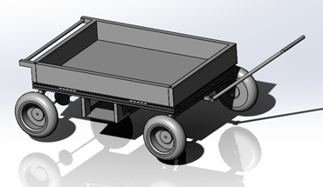
Figure 16: CAD Model of Final Design

5.2 Implementation Plan
The plan going forward is to create a prototype or proof of concept. This will allow the group to show that the design is realistic and can further their project to create the final product. Information that will be needed for the final design will include the results of the tests from above, as well as the durability and strength of the given materials. Finalizing the dimensions after the prototype will also be used to create the final design. Everyone on the team is a valuable asset to the project, and the client and instructor are useful sources to refer to when building the design. A representative from the 80/20 company may be used but isn’t completely necessary. The materials that will be used will be mostly aluminum. Some standard steel may be used for smaller components such as the handle. Parts such as the motor, jack, axles, and gears can all be outsourced from other companies. Facilities that may be used during the process include the Machine Shop, the team’s houses, and possibly other places with the desired equipment for use. A Bill of Materials can be found in Appendix B.
For the second semester, the initial plan is to have a proof-of-concept either completed or close to completion. It is also a plan to have the parts necessary to start construction. As the building process progresses, small changes may need to be made in order to fit the desired outcome. Once construction is complete, tests will be conducted to determine the proper gear ratio as well as the maximum capacity. Any parts of our budget may be used to replace any parts that may be broken in this process. From there, a presentation to the client will be conducted and their input will be given to make any small adjustments.

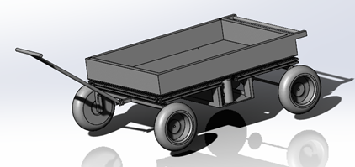
Figure 17: Another View of the Assembled Design.

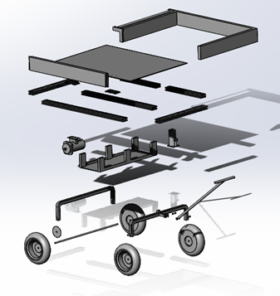
Figure 18: An Exploded View of the Design.

IMPLEMENTATION – Second Semester
The team's goal for implementing the build of the cart was to send all the items to Connor’s house, one of the team members, and build it in his garage. The team shortly found out we could only send big products there so most of the items ended up getting shipped to the engineering build and the team would pick them up. The team met around once a week to either build or meet at a store to buy more products if needed. The team's biggest problem we encountered was finding correct tires for the device. We ordered a total of five tire orders, one which was lost, one that only fit the front tire axle, two which were out of stock by the time the engineering department approved them, and one that we finally used. Below includes more information in our second semester design changes and manufacturing and assembly plan.

Design Changes in Second Semester
Since the beginning of the semester, a lot has changed for the final portion of the project. The largest part that has changed is the materials being used. The client decided that a prototype would be best and because of this, it would be okay to use wood as the material for the building of the bucket. The main reasoning behind this is because the original intent was to be able to take this to Malawi, but the client found it to be more difficult to do so than expected. The change was made to make it easier to build in the United States and keep it in the United States until further advancements are made in the transportation of the device. Using wood will also make it easier to construct and deconstruct which could help when the transportation is figured out. The dumping mechanism was also slightly changed. The removable door when dumping will no longer have dovetails that fit into the stationary walls, but rather will have removable pins that will keep the door in place when needed. This change was made to make it easier to machine the parts. It is quite difficult to machine a perfect-fitting dovetail of that length, and the dovetail can easily be broken if handled incorrectly. The pins will be much easier to remove and replace when needed.

Design Iteration 1: Change in [subsystem/component] discussion
The team was going to use the hydraulic rods as the dumping mechanism at first. The workers will be allowed to remotely control the motor to expand and extend the hydraulic rod to realize dumping. However, through communication with customers, if the team uses a hydraulic rod, the manufacturing cost and maintenance cost will increase, and the team finally decided to use the 4-ton hydraulic jack. In this semester, the 4-ton hydraulic jack is sold out, so the team decides to use an 8-ton hydraulic jack instead. The manufacturing costs are slightly higher than before, but the 8-ton hydraulic jack will allow the team to transport and dump more composts. Besides, the team will place the hydraulic jack on the basket underneath the cart. Since the handle of the hydraulic jack is too short to reach, the team will attach several PVC tubes to lengthen the handle.

Manufacturing and Assembly Plan
The teams plan in manufacturing and assembling the cart was to meet up every week once the materials started coming in. The team would either meet at a store to buy materials needed or meet at Connor’s house as he has agreed to let us use his garage to build the cart. The team would work together and build the cart as the materials came in. Below are some pictures of the team in the garage when we met.
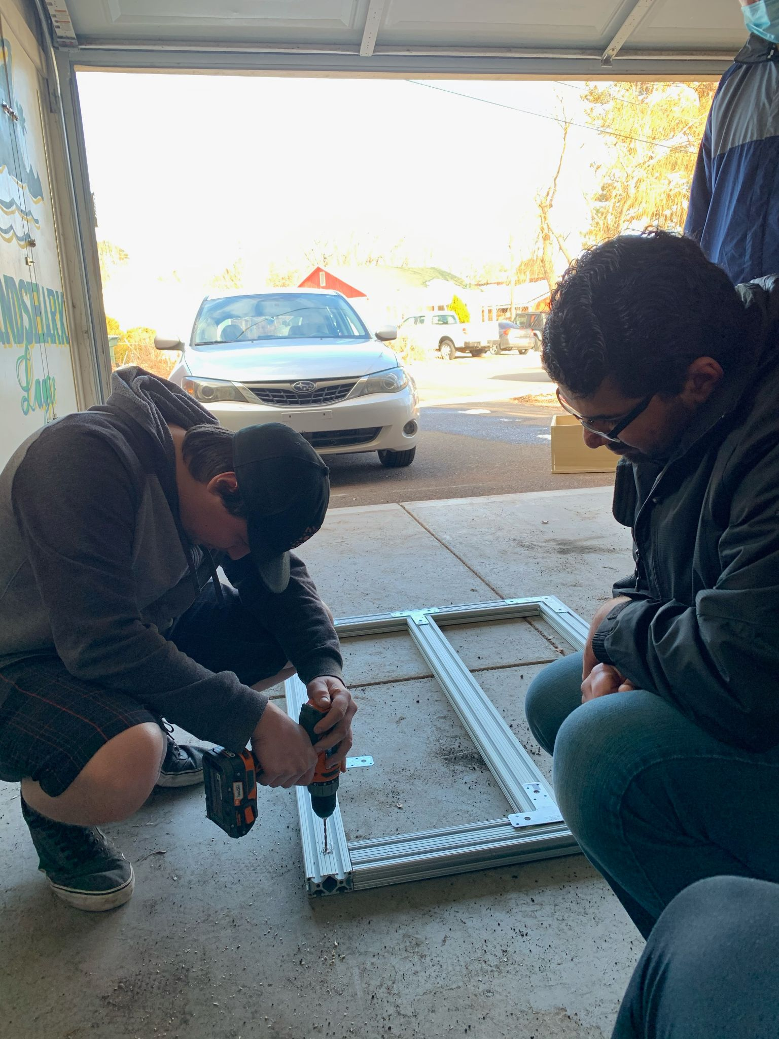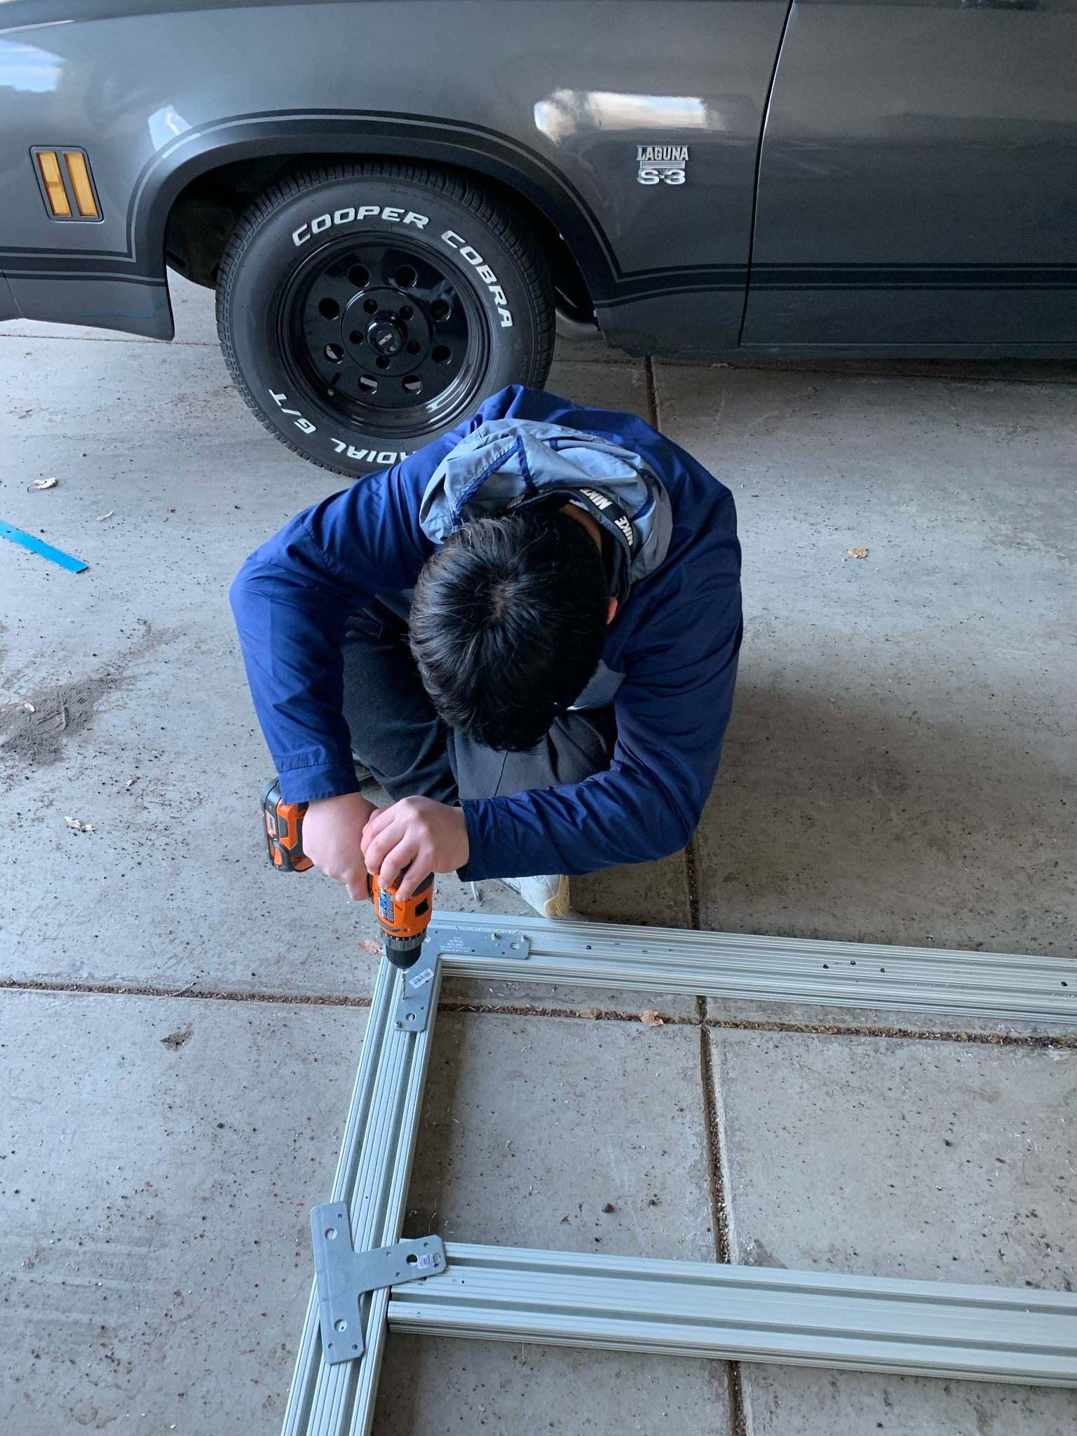
Figure 19 and 20: Assembling the 80/20 Aluminum Base
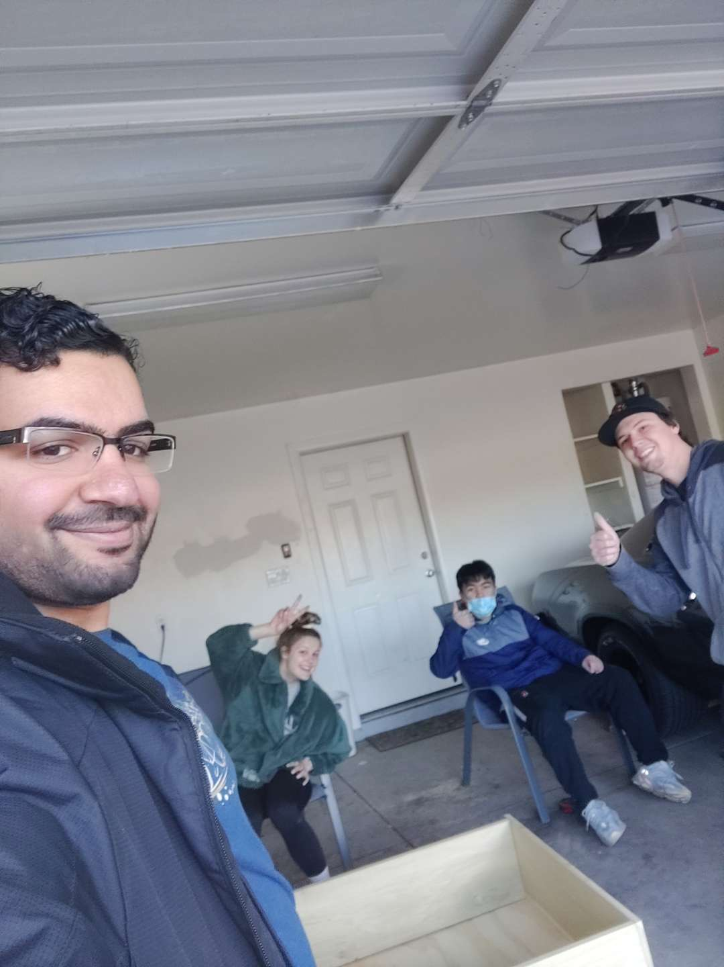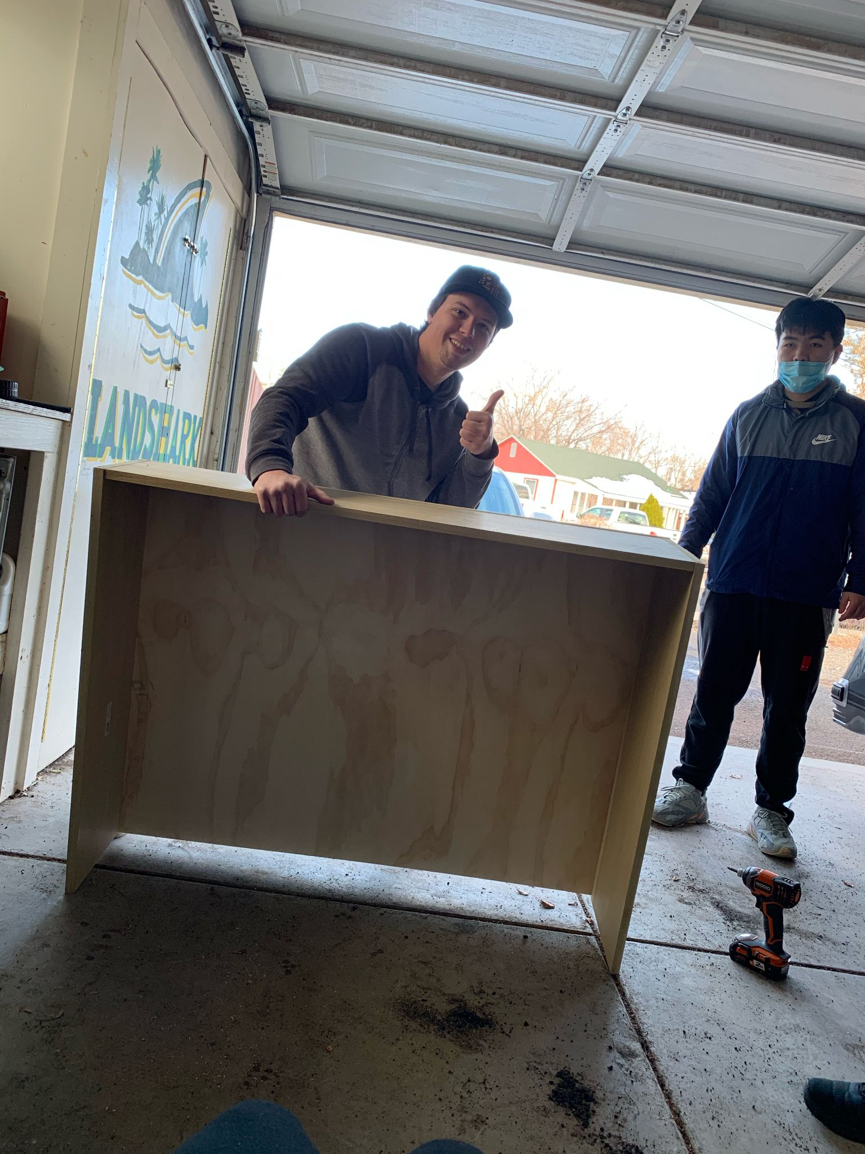
Figure 21 and 22: Attaching the Wood Frame to the 80/20 Aluminum Base

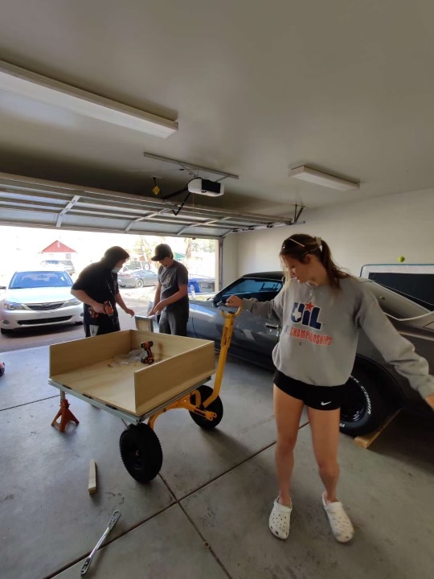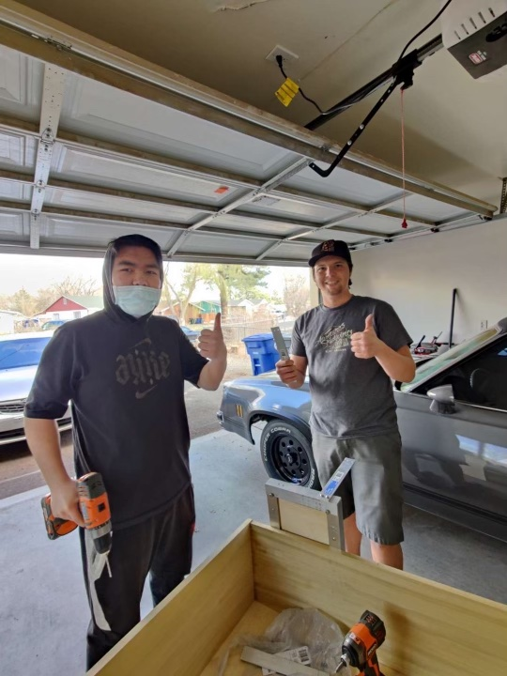

Figure 23 and 24: Assembling the Basket and Handle

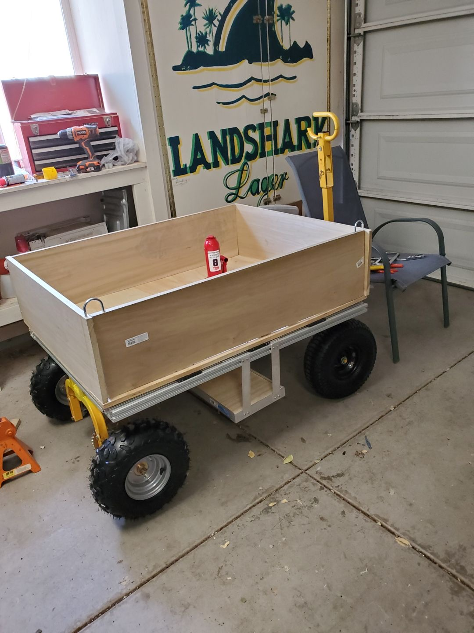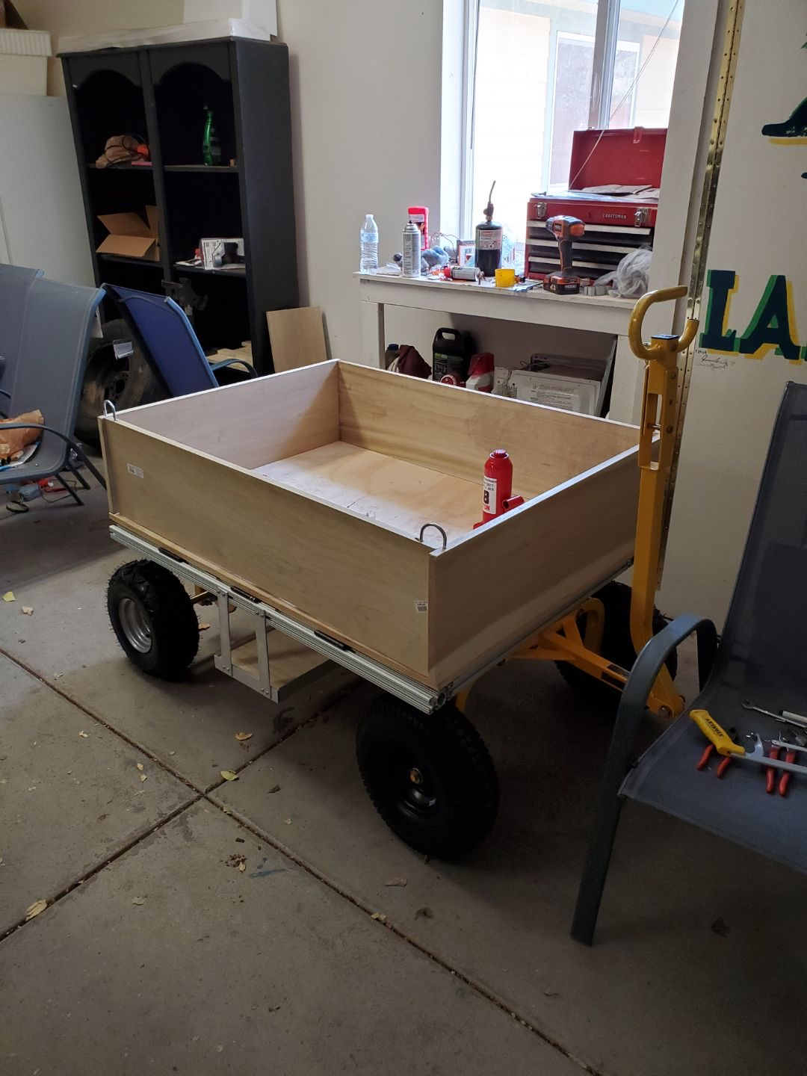
Figure 25 and 26: The Current State of the Design

RISK ANALYSIS AND MITIGATION
This section will discuss the risk analysis of the project, and what actions were taken to mitigate these risks. In every project, there will be some failure points. It is important to note these points and ensure that they are taken into account for the final design.

Potential Failures Identified First Semester
In the beginning of the first semester, the scope of the problem started to sound like a problem. The initial idea seemed way too large for something that must be completed within two semesters. It was realized later this semester that the tires may be a potential issue for this project. Not only are the proper tires needed, but finding these tires in a timely manner may pose a problem.

Potential Failures Identified This Semester
Upon construction of the design, the team has identified potential problems in the future. There are three major points to discuss. The first that was recognized was the construction of the frame. The team could not get the proper 8020 connectors in time so the frame had to be built using other methods. This posed a possible problem in the stability and rigidity of the frame.
Another source for possible failure is also with the strength of the frame. Upon constructing the frame, when the jack lifted the load of the cart, the frame would start to bend slightly on the side that the jack is on. This is because a cut was made in the frame as a place for the jack, but this turned out to be something that wasn’t ever needed. The team would need to look into this part more so that the frame was strong enough to lift the loads of the cart with no problems.
One final potential failure in the project is the speed controller of the electrical system. The team was planning on implementing only 24 volts to the motor through the controller, but after a discussion with Dr. David Willy, the speed controller may require the full 48 volts even though the motor does not. This happened towards the very end of the semester so this is something that may not be complete in time.

Risk Mitigation
Each of the potential failures were luckily realized before it was too late. At the beginning of the first semester, the scope was to build an electric tricycle with a small truck bed attached to it. This was discussed further and it was soon realized that this was too large for four people and two semesters. The scope was then changed to something much more possible. The new scope is what is described in the rest of this report: an electrically-assisted cart that has hydraulic dumping. This design would act as a prototype for the client and be a multi-year project.
The tires never stopped being a problem until the end of the semester. With various shipping issues and vendor issues, the team couldn’t seem to get the proper tires in a timely manner. However, it was decided that the front tires would be on bearing and roll independently to make steering easier. The rear tires would be attached to each other through an axle, so that they can be electrically maneuvered by the motor and a chain setup. This means that the team needed two different types of tires which made the hunt even more difficult. The rear tires ended up being shorter than the fronts so the rear axle was machined to account for this height difference.
The frame posed multiple possible problems that needed to be addressed. When the 8020 material first came in, it was expected to use the 8020 connectors to make it as stable as possible. The connectors couldn’t come in in a timely manner so other options needed to be explored. The team decided to use right angle connectors and t-connectors and screwed these into the frame. This was done on each side of the frame to ensure the stability of the frame.
Another aspect of the frame that posed a problem was the rigidity once a cut was made for the hydraulic jack. This was done because it was initially intended that the hydraulic jack would be mounted in one place. When testing began, it was realized that as the jack lifted the load, this weight being applied to the jack and in turn the basket underneath resulted in the frame to bend in the place it was cut. It was later realized that this cut shouldn’t have been made as it would be more beneficial to have the jack be placed wherever needed. This would be a lesson learned for the next prototype, but since the cut was made already, a support needed to be made for it. Aluminum beams were acquired and were used to support this area to the rest of the frame. The bending has decreased heavily because of this.
The speed controller was the most recent problem that the group was faced with. Upon wiring the motor up with the throttle and speed controller, the team was faced with the problem of the throttle not activating the motor. This was very unexpected as all of these components are brand new. After careful consideration and discussion with multiple professors, the conclusion was made that the cart needs 48 volts instead of 24. While the motor can run off of 24 volts, the motor controller itself seems to have a minimum voltage of 41. Two more batteries were purchased to accommodate for the extra voltage.

ER Proofs
The group agreed to come up with a list of engineering specifications and requirements while planning and also during the building and testing phase, after hearing what the client needed for this project. The engineering requirements are things that can be measured and items that can be discussed quantitatively. The engineering requirements are listed as follows:

- Compact Size with lightweight | - High Capacity Battery | - Cost-Efficient

ER Proof #1 – Compact Size

3x4ft Bed-Target = 12 sq. ft. with 6in. high walls
This target was created because it is important to the client that this cart can fit well on the roads of Malawi which are known to be narrow. Because of this, the requirement was made to make sure that the cart didn’t exceed a certain width. However, the client wanted to be able to still maximize the amount that can be carried, therefore the length was elongated slightly and the height of the walls was made taller as well.

3x4ft Bed-Target Tolerance = +/- 2 in
The tolerance on this project is going to be very small due to the importance of this size. A 3x4ft be is an optimal size to have a decent area but still have a narrow width. The size of the wall is where this tolerance may impact the project the most. A 6-inch wall is a decent middle ground, but it may be possible to achieve an 8-inch high wall. This will not affect the height dramatically and will even add some volume to the amount that can be transported in one trip.

ER Proof #2 – High Capacity Battery

Capacity of at least 10 Amp-hours- Target = 10 Ah
The motor that was purchased has a maximum voltage of 48 volts. With this, it is rated at 20.8 Amps which puts out a power of just under 1,000 Watts. This will give us about 600 rpm for the shaft rotation from the motor. And as long as the calculations are correct, the gearing that was chosen should allow for a proper speed. A higher-capacity battery is wanted because it is going to take quite a bit to keep the motor running for an extended period of time.

Capacity of at least 10 Amp-hours - Tolerance = +/- 2Ah
The group decided that 8Ah would be an acceptable capacity as this rating is accounting for a constant draw and the device will not be used constantly. This is, however, the baseline so the aim is to get a slightly higher capacity to maximize the capabilities. It is better to go for more capacity because it will account for any long days where the device may be used more or any other possible variables such as parasitic draw. This tolerance will allow the project to accept higher capacities without going below the minimum requirement that was set by the group.

ER Proof #3 (changed from fall): Cost under $1,500

Cost under $1,500 - Target = $1,250
The team's budget is $1500. The team believes that, according to the current bill of material, the current total budget should not exceed $1250, and $250 should be reserved for expenses incurred in response to some emergencies. Table 1 shows all the current materials that the team is going to use to build the prototype.

Table 1: Current Bill of Materials for the Project.
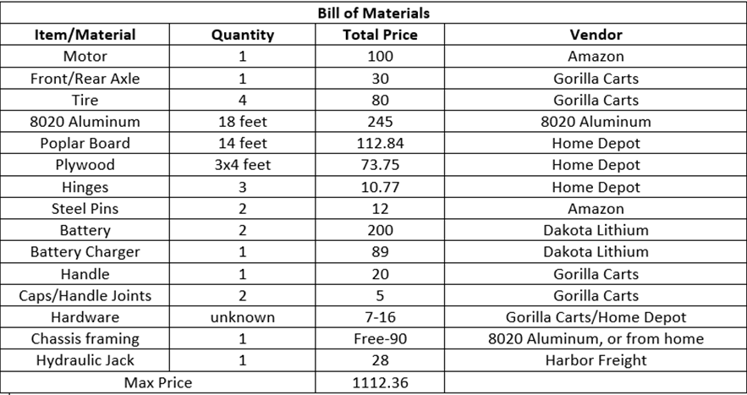

However, the second semester brough on more charges than the team originally anticipated. Table 1 above shows the Bill of Materials the team put together the first semester and did not include all of the little items that the team would need. The actual final Bill of Materials was actually still under the $1,500 budget, but not under the $1,250 budget the team was targeting for.

Cost under $1,500 - Tolerance = +/- $387
The maximum cost for this project is now set at $1,500, but the team is set to design towards only using $1112.36 to allow a contingency of $387.64. Besides, customers can provide tools for the team at the time of assembly, which will reduce the cost of purchasing tools for the team. The panel believes that the final cost will not exceed $1250, which satisfies the cost-efficient engineering requirement. This relatively low-cost and efficient vehicle will help people in Malawi better transport the composts.

LOOKING FORWARD
Below are the future testing procedures and future work will be done by the team. The DC motor test needs to be conducted because too much power would cause the design to be too fast for walking, while too little would cause it to be too slow for rougher areas. A proper gear ratio will allow for proper power transfer and a proper power amount. Also, the 500 pounds load test will help the team find out the maximum weight that the cart can carry. Last but not least, the team will conclude the future work needs to be done.

Future Testing Procedures
The future testing procedure includes getting the motor to work with the batteries, electronic throttle, and speed controller. We are hoping to get the help of someone from the electrical engineering department as our knowledge on motors and wired is very limited. After getting this part working, the testing with load upto 500 pounds could also be tested. We have just been using ourselves and estimating our weight, but other heavier supplies can be used as well.

9.1.1 Testing Procedure 1: DC Motor

Testing Procedure 1: Objective
This test will be conducted in order to find the best power for the DC motor. This test needs to be conducted because too much power would cause the design to be too fast for walking, while too little would cause it to be too slow for rougher areas. A proper gear ratio will allow for proper power transfer and a proper power amount.

Testing Procedure 1: Resources Required
The whole team will help to run this test. Since the team has already got the gear, the team still needs to have a stopwatch to determine the time to travel a certain distance, which will then be used to calculate the speed. This test will be run at Connor’s garage.

Testing Procedure 1: Schedule
Since the motor needs a 48V power supply to work, the team will run this test when the 48V power supply is delivered. The whole test will be done within one day in the upcoming week.

9.1.2 Testing Procedure 2: 500 Pound Load

9.1.2.1 Testing Procedure 2: Objective
Since the team has finished building the cart, the team will test it by seeing how the device runs with various loads applied. The team, when ready, will test up to 500 pounds as that is the maximum load the client has specified.

9.1.2.2 Testing Procedure 2: Resources Required
The team plans to use 500 pounds sand to do this test. Since it is easy to increase or decrease the weight of sand. The test will be done in the upcoming week, the team will meet and test it at Connor’s garage, and get the test done within one day.

9.1.2.3 Testing Procedure 2: Schedule
The test will be done within one day, since the team will simply increase or decrease the weight of sand. Also, the team will test the maximum weight that the cart can dump. Before the test, the team will double check if the cart is in a good condition to run the test to prevent any damage from happening.

Future Work
The current design is the first prototype of a multi-year project. This prototype is a good start to this project. The future of this project will continue past this year and will be built off of this design. Multiple changes will be made in the process, such as keeping a solid frame instead of cutting it as discussed in the failure section above. A different lifting mechanism may be implemented in the future depending on if an easier solution can be found. Due to COVID, a lot of the supplies took longer than expected to get delivered for our project. Hopefully, in the future, the access to these parts will become much easier and become much quicker.

CONCLUSIONS
Apart from being a small landlocked nation in Africa’s southeastern region, Malawi is also regarded as one of the world’s poorest countries. For better utilization of organic materials found in this country, residents have set up places for disposing of compostable waste materials. To ensure easy transportation of these compostable waste materials, our team has been mandated to design and make a vehicle that is able to transport compost to the composting location. The group was acquainted with the customer that will be with us for the degree of the semester and further if the venture is to be proceeded. At this stage, the team has completed the construction of the vehicle, and will complete the motor and variable speed throttle test in the upcoming week.

Reflection
Since our team has been mandated to design and make a vehicle that is able to transport compost to the composting location. In order to bring convenience to Malawi people and ensure the safety of the operators, fail-safe, low manufacturing costs, and high capacity were the most important factors to the project. After two semesters of hard work, the team finally decided to use the jack as the dumping mechanism. The advantage of using the jack is that it can bear a large weight and will not break. In addition, the team improved the design of the 8020 aluminum frame to make the whole frame more stable and robust. Besides, the team makes sure that the budget of the project is under 1500$, if the vehicle is put into production, the manufacturing price may even be lower. For the capacity of the vehicle, Malawi people can further improve the capacity of the car by increasing the height of the board, which is convenient for them to transport more composts at a time. Considering that the road environment of Malawi is mostly muddy, the team members chose the right tires, whose rough lines can provide more friction for the car, which is more suitable for the local situation. In addition, the team used variable speed throttle to deal with various situations. For example, the high-speed mode can be used when uphill, which will make it easier for local people to use.

Post Mortem Analysis of Capstone
The team discusses below the success and challenges that came out of this project. Furthermore, this section will discuss all of the things that happened throughout the year and will explain how they affected the overall outcome of the project. Below describes more in-depth what the team believes contributed to the project and what areas the team can improve upon.

10.2.1 Contributors to Project Success
Last semester, our team was created to build an efficient transporter that can transport organic waste from dense neighborhoods to composting sites in Malawi. The design will be an electrically assisted/propelled transporter that allows the people of Malawi to transport organic waste from homes, ditches, and rivers to the compost site. For the project goal, we want to make the transporter durable and maintainable by using the reusable materials found in the country of Malawi. We also want to keep the project budget low due to Malawi's financial state. The team's overall quality goal is to make sure it works and satisfies the customer and client needs. We are not trying to design the prettiest design but rather a safe, efficient, affordable, and maintainable one. In order to complete the purpose and goals, our team has come up with multiple goals and steps. In the weekly meeting with the client last semester, our team members shared our ideas with the client. In the process of continuous improvement, our team determined the sketch of our final design, which completed the purpose and client and customer goals perfectly.
In order to achieve the purpose and goals of the group more efficiently, the group made a series of ground rules. Our team plans on meeting through a weekly zoom call with our professor, to always be on time, to continue to stay focused on the task at hand, to communicate efficiently, and to respect everyone's opinion. The team will also keep the client updated throughout the progression of the project to make sure we stay on the right track of her needs and the needs of the customers. Also, in order to make decisions, the team has decided to have everyone share what they think about a certain area of the project and then discuss how to proceed. This lets everyone have a chance to be heard and all ideas can be discussed. If any teammates were to get into a disagreement, we will settle it respectfully. We will listen to any participating parties and figure out what the best course of action to take would be. Meanwhile, we will hold each member accountable for their own actions and everyone is expected to give the project a full commitment to all the tasks assigned to them. Each member should be responsible for all the work submitted on behalf of the whole team. All the ground rules and coping strategies have been followed and our group has excelled in the capstone project. Our group chose to meet via Zoom meeting every Tuesday afternoon to discuss new progress, report to clients, and get feedback. Through continuous improvement, we got the sketch of the final design last semester and managed to create a viable prototype this semester. In the weekly zoom meeting, no members are late or absent without earlier notice and everyone's opinions are respected. Because each of us is responsible for different parts, there are no differences among members, and the whole process goes very smoothly. We also got A+ in the last semester, and the members completed all assignments with good quality work.
The team dynamic played a huge role in the success of this project as discussed above. However, the team also succeeded through the use of everyone’s participation and skill sets. Each member had their own set of skills that played well with this project so that it could get done properly. Throughout the entirety of this project, each member continued to show a drive for this project and there wasn’t one time where the team had issues with each other or the scope of this build. Overall, these were the driving factors for the success of this project. The team’s work dynamic and their individual contributions proved to be something that this project would have failed without.

10.2.2 Opportunities/areas for improvement
In terms of opportunities for improvement, the team has reached most of its goals for the previous semester. The only part that has changed since the team charter is the overall scope of the project. In the team charter, it was said that a tricycle would be constructed but that has since been changed into a much more doable project for one year. The most positive project performance would be sticking within the budget. We managed to stay well within the given budget when it was worried about for the first part of last semester. The most negative aspect of last semester would probably be time management. This is mostly due to the ongoing pandemic and the unexpected nature it has given us. However, this being said, we still managed to stay on track and be mostly caught up. As stated previously, the largest obstacle that has been encountered has been the pandemic. It has been difficult to do anything in person, as well as being able to track certain items that have been shipped. Because of this, the scheduling of the build kept being postponed. This made it feel very rushed at the very end, but nonetheless it was still manageable.
Through the last semester, many lessons have been learned and we have been able to adapt to the best of our ability. The client’s vision can vary on occasion, but this is no issue as the client’s needs would be constantly changing in the real world. One aspect of this project that has changed since the beginning is the weight of the project. It was always a goal to keep the cart as light as possible, but the client recently made it clear that this should be one of the top priorities. We have all learned more technical lessons through the self-learning assignments that will help to improve our goals continuing forward. However, working as a group and within this group, we’ve managed to learn a lot from each other.

REFERENCES
[1] N. Takesue, Y. Komoda, H. Murayama, K. Fujiwara and H. Fujimoto, "Scissor lift with real-time self-adjustment ability based on variable gravity compensation mechanism", Advanced Robotics, vol. 30, no. 15, pp. 1014-1026, 2016. Available: 10.1080/01691864.2016.1181008.

[2] A. Noormohamed, O. Mercan and A. Ashasi-Sorkhabi, "Optimal Active Control of Structures Using a Screw Jack Device and Open-Loop Linear Quadratic Gaussian Controller", Frontiers in Built Environment, vol. 5, 2019. Available: 10.3389/fbuil.2019.00043.

[3] P. Gallina, "Vibration in screw jack mechanisms: experimental results", Journal of Sound and Vibration, vol. 282, no. 3-5, pp. 1025-1041, 2005. Available: 10.1016/j.jsv.2004.03.036.

[4] Xiang Sunshou Seeks Patent for Garbage Recycling Vehicle with Hydraulic Lifting Rods. (2018). Global IP News. Environmental Patent News, pp. Global IP News. Environmental Patent News, 2018-04-08.

[5] J. Wang, Z. Qi and G. Wang, "Hybrid modeling for dynamic analysis of cable-pulley systems with time-varying length cable and its application", Journal of Sound and Vibration, vol. 406, pp. 277-294, 2017. Available: 10.1016/j.jsv.2017.06.024.

[6] 8020.net. 2020. Resources To Learn More About T-Slot Products And Narrow Down Your Options.. [online] Available at: <https://8020.net/product-basics#> [Accessed 19 October 2020].

[7] Budynas, R., 2019. SHIGLEY's MECHANICAL ENGINEERING DESIGN. 8th ed. MCGRAW-HILL EDUCATION.

[8] Orosz, I., 1970. Simplified Method For Calculating Shear Deflections Of Beams. Madison, WI: USDA Forest Service, Forest Products Laboratory.

[9] Engineeringtoolbox.com. 2008. Aluminum Alloys - Mechanical Properties. [online] Available at: <https://www.engineeringtoolbox.com/properties-aluminum-pipe-d_1340.html> [Accessed 19 October 2020].

[10] Megson, T., 2005. Structural And Stress Analysis. 2nd ed. Boston: Elsevier Butterworth Heineman.

[11] Lowe's. 2020. CRAFTSMAN 6-Cu Ft Steel Wheelbarrow. [online] Available at: <https://www.lowes.com/pd/CRAFTSMAN-6-cu-ft-Steel-Wheelbarrow/1000737276> [Accessed 19 October 2020].

[12] Amazon.com. 2020. Gorilla Carts GORMP-12 Steel Dump Cart With Removable Sides And 2-In-1 Convertible Handle, 1,200-Pound Capacity, 39.5-Inch By 22-Inch Bed, Grey Finish. [online] Available at: <https://www.amazon.com/Gorilla-Carts-GORMP-12-Removable-Convertible/dp/B00814KE5I> [Accessed 19 October 2020].

[13] The best vintage and classic cars for sale online | Bring a Trailer. 2020. 1954 Cushman Truckster Pickup. [online] Available at: <https://bringatrailer.com/listing/1954-cushman-truckster/> [Accessed 19 October 2020].

[14] University of Colorado Boulder, “8. DC vs. AC Motors - DC Motor Control and Stepper Motors,” DC vs. AC Motors. [Online]. Available: https://www.coursera.org/lecture/motors-circuits-design/8-dc-vs-ac-motors-gf0y2. [Accessed: 19-Oct-2020].

[15] All About Circuits, “Brushless DC Motor: AC Motors: Electronics Textbook,” What's the difference between brushless DC motors and AC motors? [Online]. Available: https://www.allaboutcircuits.com/textbook/alternating-current/chpt-13/brushless-dc-motor/#:~:text=Brushless DC motors are similar,torque in a magnetic rotor. [Accessed: 19-Oct-2020].

[16] RS Components Ltd., “The Complete Guide toAC Motors,” Everything You Need To Know About AC Motors | RS Components. [Online]. Available: https://uk.rs-online.com/web/generalDisplay.html?id=ideas-and-advice/ac-motors-guide. [Accessed: 19-Oct-2020].

[17] Balls Out Motors, “Golf Cart Buying Guide,” NEW & USED GOLF CART BUYING GUIDE. [Online]. Available: https://www.ballsoutmotors.com/golf-cart-buying-guide/#:~:text=Most newer golf carts now,more pulling power up hills. [Accessed: 19-Oct-2020].

[18] Electric beach wagons, Sandhopper.com & Electricbeachwagons.com. [Online]. Available: https://electricbeachwagons.com/. [Accessed: 19-Oct-2020].

[19] “Why foam-filled tyres are the best choice for your telescopic boom lift,” Why foam-filled tyres are the best choice for your telescopic boom lift | TVH Parts, 19-Apr-2019. [Online]. Available: https://www.tvh.com/blog/why-foam-filled-tyres-are-the-best-choice-for-your-telescopic-boom-lift. [Accessed: 19-Oct-2020].

[20] “Manufacture of microcellular foam tires,” Google Patents, 20-Jul-2010. [Online]. Available: https://patents.google.com/patent/US5229047A/en. [Accessed: 19-Oct-2020].

[21] N. Ward and T. Young, The complete guide to glues & adhesives. Iola, WI: Krause Publications, 2001.

[22] “Effects of Summer Heat on Adhesives,” Bond Tech Industries, 22-Jul-2015. [Online]. Available: https://www.bond-tech-industries.com/effects-of-summer-heat-on-adhesives/. [Accessed: 19-Oct-2020].

[23] HNX Media, “Expanding Foam In A Tire,” YouTube, 14-May-2019. [Online]. Available: https://youtu.be/chcEBR4h8Is. [Accessed: 18-Oct-2020].

APPENDICES

Appendix A: Design Alternatives
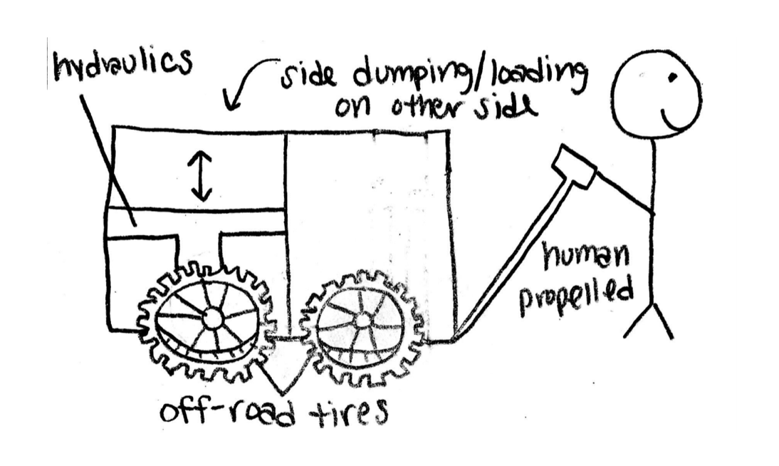
Figure A1: Design Alternative 1

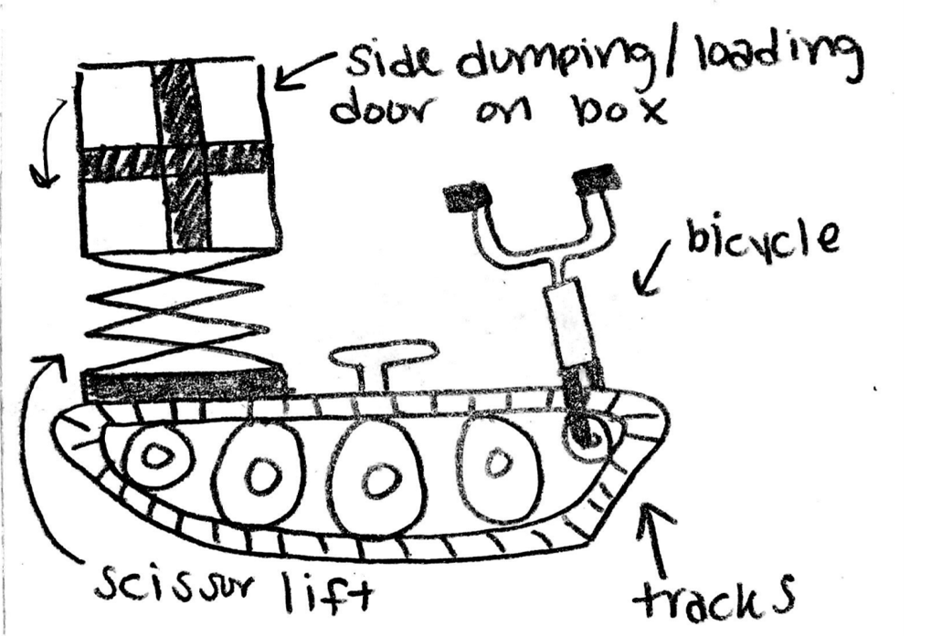
Figure A2: Design Alternative 2

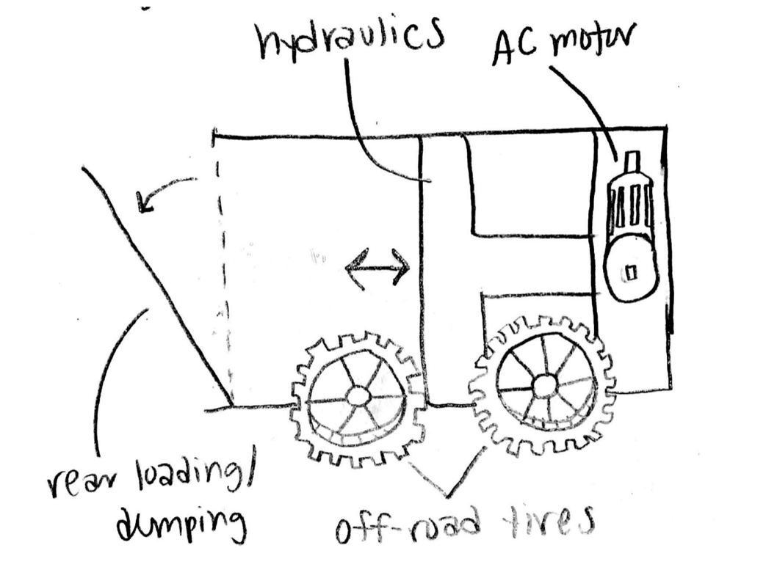
Figure A3: Design Alternative 3
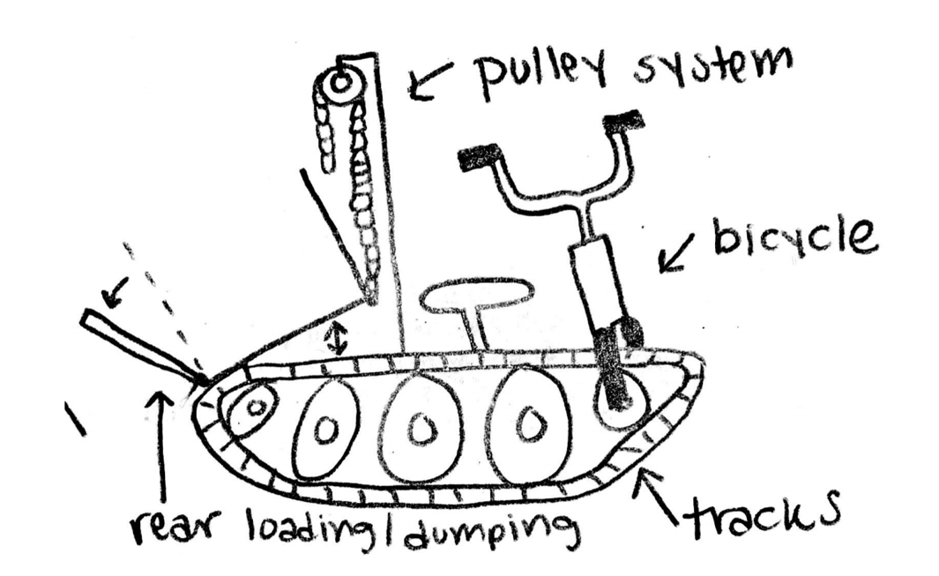
Figure A4: Design Alternative 4

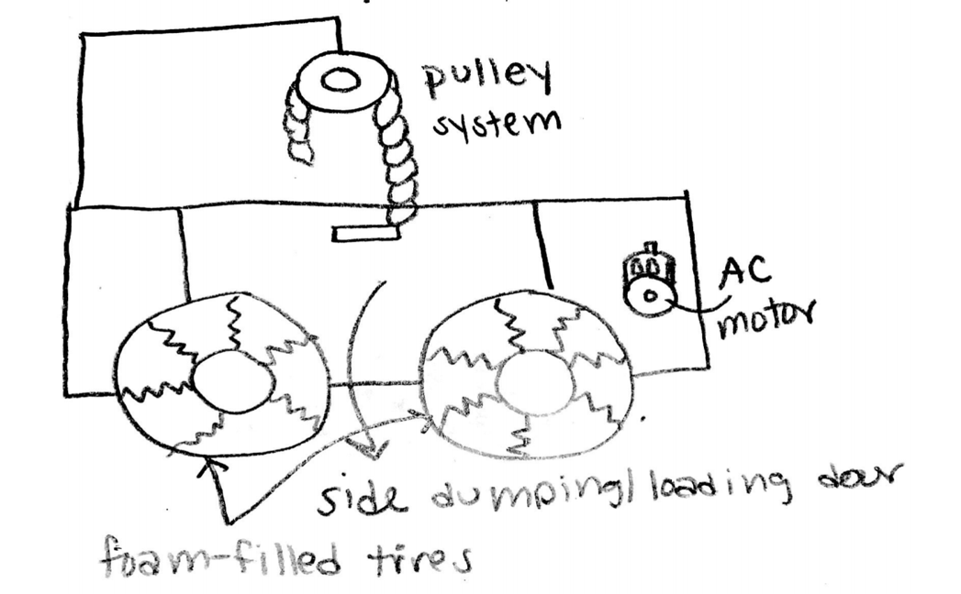
Figure A5: Design Alternative 5

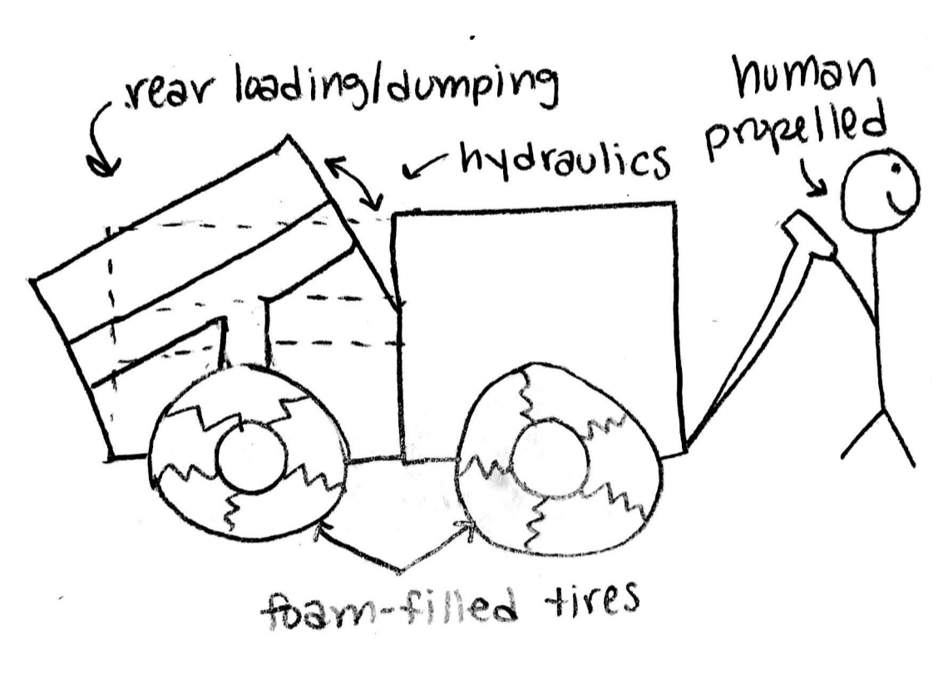
Figure A6: Design Alternative 6

Appendix B: Important Tables

Table B1: Pugh Chart
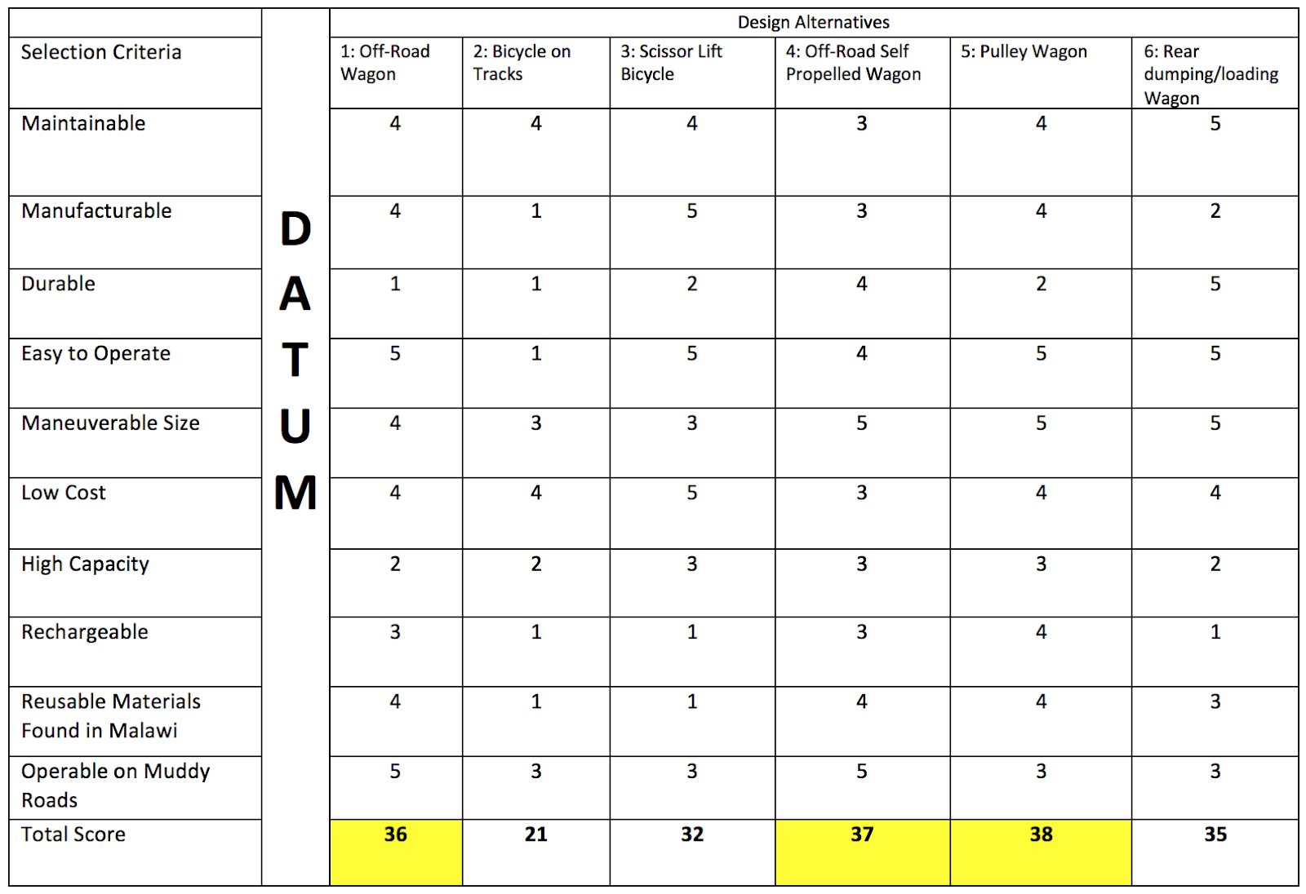

Table B2: Decision Matrix

 |  | Off-Road Wagon |  | Off-Road Self Propelled Wagon |  | Pulley Wagon
Criteria | Weight (%) | Score | Weighted Score | Score | Weighted Score | Score | Weighted Score
Increase Power | 15 | 1 | 0.15 | 4 | 0.6 | 4 | 0.6
Small Dimensions | 20 | 5 | 1 | 2 | 0.4 | 2 | 0.4
Increase Waste Capacity | 25 | 3 | 0.75 | 3 | 0.75 | 4 | 1
Increase Battery Life | 10 | 1 | 0.1 | 3 | 0.3 | 2 | 0.2
Decrease Weight | 10 | 5 | 0.5 | 3 | 0.3 | 3 | 0.3
Decrease Manufacturing Cost | 20 | 5 | 1 | 1 | 0.2 | 1 | 0.2
Total |  |  | 3.1 |  | 2.55 |  | 2.7

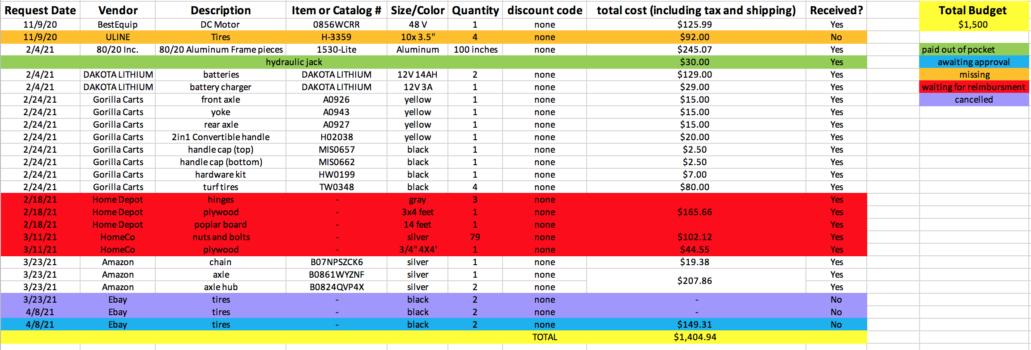
Table B3: Bill of Materials

